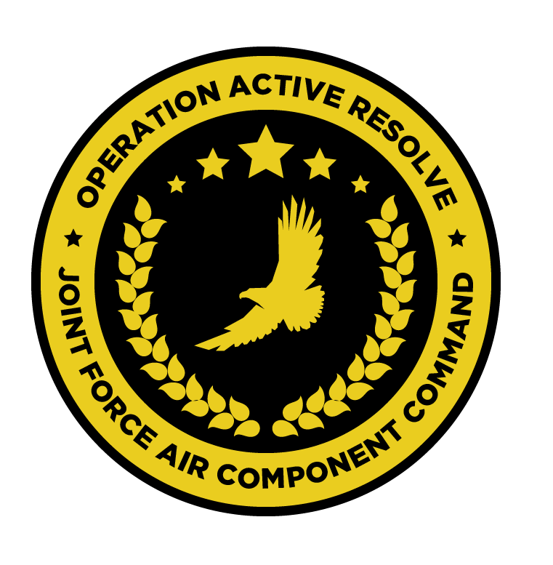

JFACC AIR OPERATIONS DIRECTIVE

OPERATION ACTIVE RESOLVE 2

D8

# 1. SITUATION

## a. JFC guidance (verbatim).

Apportionment:

* DCA: 5
* OCA: 40%
* Strike/Air Interdiction: 20%
* Support LCC: 30%
* AR:10%
* CAS: 20%
* Support MCC:
* ASUW/NTISR: 5%

Priority of effort is on establishing Air Superiority in support of LCC and set conditions

for own operations.

* Start shaping for phase 2 in the operation (Create permissive environment).
* Start strike operations in Syria as applicable.
* Continue support to LCC in effort to free Turkey.

o RESTRICTION: Reduce/limit AR operations in Syrian territory until LCC have made a plan for the ground offensive into Syria. Focus the effort on CAS and AR in direct support close to the friendly forces in Turkey.

* Start supporting MCC by monitoring the situation in EMED with two SAGs from Russian and China arriving in the area of operation.
* Be prepared to prepare contingency plans for striking Syrian WMD at short notice (regardless of phase). Expect this plan to be asked for prior to commencing phase 2. ALR: HIGH approved for such a plan.

## b. Enemy situation.

The current enemy situation is defined in VIS INTSUM D7, available at OPAR BRIEF.

## c. Friendly situation (by joint force component).

### Land Component Command (LCC)

#### IV Corps

The 55th Mechanized Division has secured HATAY and have moved forward battalions to screening positions along the FLOT.

56th Armor Division has its forward elements at the southern outskirt of Gaziantep and are

moving according to LCC plan. Gaziantep Airfield is now fully under allied control and

shipments of fuel and ordnance have started to arrive. The airfield can now be used for AH-

64s and A-10s.

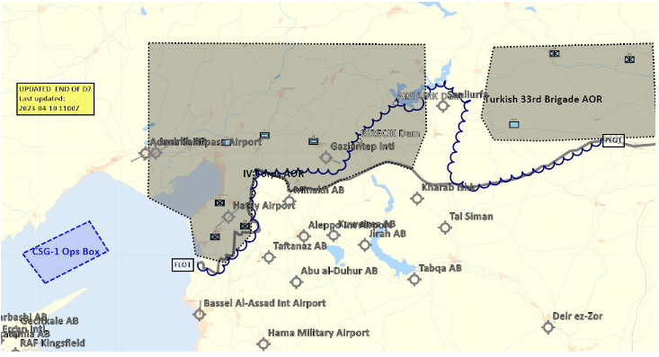

#### Turkish local forces

The Turkish 33rd Brigade have been neutralized and Syrian forces have now taken

control of Sanliurfa

### Maritime Component Command (MCC)

CSG-1 continues to support the mission from CSG-1 operations box.

SAG 1 remains outside the AO, having been directed to support shipping movements elsewhere.

### Special Operations Component Command (SOCC)

SOF teams are standing by to support with reconnaissance as required and requested by JFACC.

* Three SOF teams were inserted into theatre in support of the observation of strategic objectives.

# 2. MISSION - The JFACC’s mission statement (verbatim).

JFACC will establish air superiority in the area of operations and defeat Syrian offensive capability in support of CJTF-82’s offensive operations to neutralize Syrian’s capability to conduct offensives in the region.

# 3. EXECUTION – AIR OPERATIONS

|  |  |
| --- | --- |
| **JFACC’s Intent**   1. **Purpose** 2. **End State** | JFACC’s intent for this day is to continue to work toward air superiority and freedom of movement as well as providing the LCC with CAS flights in order to support the ground offensive to push out Syrian forces out Turkey  Priorities are:   1. Support the LCC with CAS flights, coordinate with LCC for information 2. Acquire intel and prosecute Syrian ground forces:    1. East of Euphrate river in KB BD    2. Killbox AE    3. Killbox BE IVO Sanliurfa 3. SEAD/DEAD in Killbox CE to clear SAM threats in that area 4. Strike SCC EAST, SYTGT068 5. Provide CAP for Turkish forces in and near Sanliurfa   The end state of this ATO sees the LCC been supported with CAS flight in order to support the ground offensive and achieve the goals set by the LCC for this day.  The SCC East, SYTGT068 will be destroyed, rendering the IADS in SCC east unusable.  Intel gained will provide knowledge about enemy force disposition and composition in KB BD and IVO Sanliurfa for further analysis and prosecution.  DEAD will attrit the SAMs in the killbox CE |
| **Execution** What to do, when. – Any detailed instructions if needed | CAS flights will operate under JTAC control in KB BC and BD, all WEST of Euphrate river.  All other flights are to remain clear of killbox BC and BD WEST of Euphrate river.  AR flights IVO Killbox BC needing to shoot in the direction of killbox BC or WEST of Euphrate river in killbox BD will contact the JTAC in charge to get clearance to fire.  Any flight may get retasked prior to the mission based on availability of flights and priorities to be fulfilled. |
| **Focus of effort by objective** | In accordance with JFACC objectives (JAOP) 3.2.2, this AOD supports the LCC in achieving its objectives as well as shape the environment for future flights and missions. |
| **Acceptable level of risk**. (including for AWACS and tankers: forward or rear) | As per SPINS**, MEDIUM** |
| **Collateral damage and civilian casualty guidance** | Every attempt should be taken to minimise collateral damage in the execution of these missions.  Suspected civilian casualties should be reported as soon as is practicable. |
| **TST guidance** | Where they are identified, items from the TST matrix must be prosecuted. The outcome should be reported on the in-flight report net. If prosecution is not possible, the location must be reported for re-tasking.   |  |  |  |  |  |  | | --- | --- | --- | --- | --- | --- | | **PRIORITY** | **TARGET** | **DESIRED EFFECT** | **RISK LEVEL** | **STATUS** | **RMKS** | | 1 | SCUD | Destroy | MEDIUM | Unlocated | N/A | | 2 | Fuel truck ATZ-10 | Destroy | MEDIUM | Likely SYTGT003/137 |  | |
| **Intelligence, Surveillance, Reconnaissance (ISR)** – If any effort should be done to support VIS with ISR to answer information gaps from VIS. | All intelligence and BDA should be submitted via Campaign Manager, and necessary images placed in #bda-reports on discord IAW SPINS.  The following IRs should be supported in this AOD:  All VIS/VID Information Requests can be found here. |
| **Other issues** | Standard Combat Loadouts (SCL) are to be used in this misson. |
| **Direction and Guidance** | Aircrews must remain clear of Jordanian airspace at all times. Munitions must not be expended which may encroach on Jordanian airspace.  Munitions may not be expended in the direction of Basel Al Assad And Tartarus in order to avoid Russian involvement in the conflict. |

# 4. ADMINISTRATION AND LOGISTICS

Due to other ongoing major military operations, the munitions are limited in accordance with the ‘available ordnance’ publication available at OPAR Brief. **Further limitations may be imposed by JFACC and will be detailed in the ATO.**

**Active Tanker Tracks –** AR701 (ARCO-1), AR803 (SHELL-3) and AR804 (SHELL-4).

# 5. COMMAND AND CONTROL

BULLSEYE NICOLE is defined at N 35 58.000 E 036 47.000.

There are no other specific C2 considerations for these missions. Refer to the Command, Control and Communications section of the JAOP.